Beginners guide to VoIP
What is VoIP and how does it work?
Voice over Internet Protocol (VoIP) is a way that allows you to make calls via the internet. VoIP users effectively gain all of the functions of traditional telephone but at a lower cost and with some extra benefits.
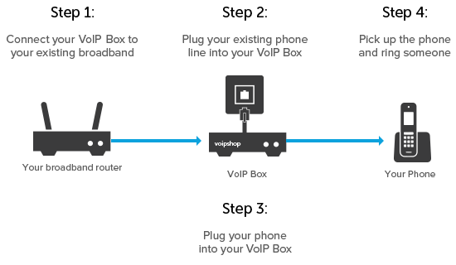
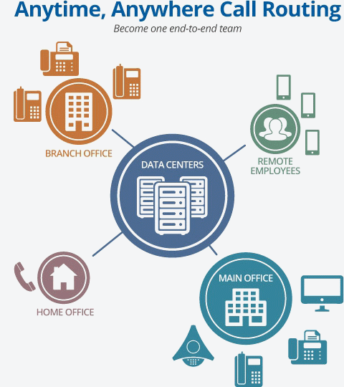
In order to make a call via the internet, VoIP converts your voice into digital signals and sends it to the other phone. The phone that you have called doesn’t have to be a VoIP phone system, your VoIP phone system can get in touch with people who are using any device, from smartphones to phone boxes, making it one of the most efficient and flexible telephone systems.

Pros and cons of VoIP
Pros:
- One of the main advantages of VoIP is that it is a lot cheaper than regular landlines. With certain setups it is completely free.
- VoIP gives you a much clearer sound, especially on a high-speed fibre optic line.
- It connects with mobile and even email. You can work on the go by routing to a mobile.
- You have more control over your business phone system and enhanced monitoring.
- If more than one person needs to make a phone call at the same time it is much better option than having multiple phone lines.
Cons:
- The quality of the call can be affected by the state of the broadband line – having slow internet could mean that the phone connection would be any good.
- There are a few things that are not available for VoIP that are available for landlines. Landlines provide customers with calling features, for instance, voicemail or call waiting. Also some numbers are unavailable to call over VoIP, such as directory inquiries.
How VoIP features work for small businesses
- Mobile clients - VoIP calls are able to be received through your mobile phone. You don't need to be in your office, you can manage your VoIP service on the move.
- Desktop clients - the desktop VoIP service is integrated with your email so when you receive an incoming call, it pops up with the caller's details from your contact directory. You'll also have the ability to simply click and call contacts, plus you can see if colleagues on the internal directory are available.
- Voicemail to email - a transcription service turns your voicemail into text and sends it directly to your phone.
- Coaching tools - you can sit in on employees calls and offer advice without clients being able to hear you, providing an invaluable training tool.
- Auto attendant - calls can be answered and callers can engage with an automated menu to avoid using extensions or receptionists.
What equipment do I need?
The exact equipment you need depends on which method of VoIP you're using.
The first thing you'll need is a broadband connection fibre optic ones are the best option as it is more reliable, an unlimited one would be preferably so you can talk as much as you need to. You'll get the absolute best VoIP experience possible with a full FTTP (fibre to the premises) or an ethernet connection, which are available with some business broadband providers.
- For VoIP with an adapter, you'll need a VoIP adapter, and a compatible phone. If it plugs into a router, you'll need a compatible router too.
- For VoIP with a computer, you'll need a laptop or desktop computer with an internet connection, the right software, and either a headset or speakers and a microphone. Headsets are better for clarity and sound quality, and have the added bonus of sparing everyone around you from hearing your whole conversation, but you can get by just fine without.
- For VoIP with a smartphone, you'll need a smartphone, connected to Wi-Fi and with your chosen app installed.

